Connection pool | consumer pool
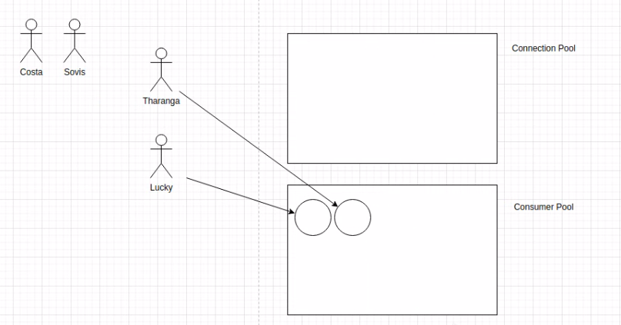

connnection pools that using:-
apache DBCP (depend on apache commons pool)

download and add to dependecies

common for all servlets → servlet context
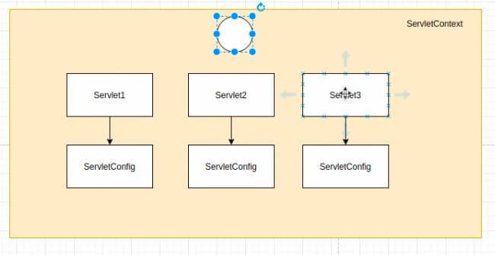

need to catch the time the serlet create and destroy → have listners for that

creating listner

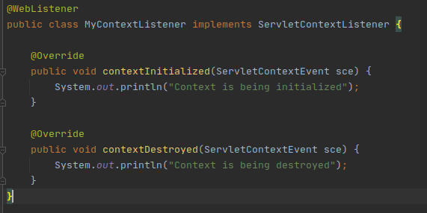

implement ServletContextListner
override these two methods
add @WebListner annotation

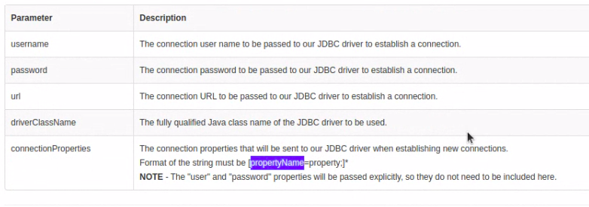
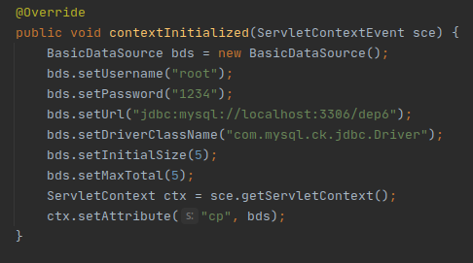

and close connection

